The Costs of Alternative Forms of Development—
What has the Evidence Shown?

Robert W. Burchell, Ph.D.
Co-director and Professor II
Rutgers University, Center for Urban Policy Research

Sahan Mukherji
Research Associate
Rutgers University, Center for Urban Policy Research

33 Livingston Avenue—Suite 400
New Brunswick, NJ 08901-1982
Phone: 732-342-3133 ext. 542
Fax: 732-932-2363
burchell@rci.rutgers.edu

Finance: The Critical Link
The Fiscal Link Between Land Use and Transportation
UCLA Conference Center
Lake Arrowhead, California
October 20, 2003

The Culture of Growth in the United States

In the United States, a development pattern is pursued that is based on a prairie psychology or horizontal determinism. The supply of land is viewed as unlimited and open to all. The forces of development are not fully understood and as such, they are not to be tampered with. Markets in the United States determine future land use, and land use professionals and their regulations and incentives prepare lands to receive development as opposed to keep them from development. (Delafons, 1969).

In addition, in the United States, there is firm commitment to the idea that Americans have a constitutional right to own property free from government interference. Also, most believe that the price to access real property is less expensive farther out in the metropolitan area. Given the above two factors, rarely is access to land limited or denied in these locations.

Further, the citizens of the United States have a general distrust of politicians so land use is codified and kept in the hands of 18,000-20,000 local governments, far away from state or federal government influence.

Growth and the Automobile

In the United States, there is also a unique relationship with the automobile. In fact, the pattern of land development is determined by the automobile. Major roadways emanating the core of cities are the axes of sprawl in metropolitan areas. Interstate highways allow sprawl to move between metropolitan areas because their origins and destinations are important places and their intersections provide a perfect home for commercial and warehousing land uses.

Without question the automobile is the most efficient and inexpensive of alternative trip choices. Low-end new automobiles may be leased for $100 (1) per month (with routine maintenance free) and combined with $125 (2) monthly insurance costs, and with 1,500 miles driven per month including the cost of gasoline and oil (an additional $100)(3), the daily cost of automobile use is $11. ((1+2+3)/30) This $11 daily cost can accommodate, on demand, a minimum of six 8-mile trips to any location, by any person on an average day. In New Jersey, New Jersey Transit’s 3-zone bus ride (5 miles) is $2.10, one-way. Six rides cost $12.60 (a mother and father round trip to work and a child round trip to a non-school location). This is already above the automobile cost and after the sixth trip, the automobile’s cost is reduced to one-third (insurance and leasing costs are fully paid for the day) whereas the transit alternative (if service is still running) remains at full fare.

Given the above, the automobile is essential and except for the highest and lowest of income categories, the number of automobile registrations does not vary significantly by income category. Further, gasoline prices at $1.80 per gallon for regular gas in the Spring of 2003 are equivalent to prices of $0.90 per gallon in the Spring of 1973. Even including the most recent spike-up, as a national average, the real price of gasoline has not changed in 30 years. By contrast, real household income has at least doubled over this same 30 year period.

Two additional lessons were learned as a result of the 1973 oil embargo. Even remembering the odd-even gasoline days and the confrontations at service station queues, households by choice continue to move farther and farther out in the metropolitan area. As shown in three census monitorings of the percent distribution of growth in MSA central city, in MSA non-central city, and non-MSA areas, the two non-city areas have grown disproportionately more than the city, with non-MSA areas experiencing the greatest relative growth.

Another lesson learned from the 1973 oil embargo was that regardless of utility costs, U.S. homebuyers would demand and U.S. builders would supply, both larger single-family homes, and single-family homes as the increasingly dominant housing type. The size of the single-family home and the percentage of single-family detached homes of all housing built have increased over the past three decades. The size of the newly-delivered single-family home today is in excess of 2,500 square feet, up from 1,800 square feet in the 1970s; the percentage of single-family detached housing built from 1990 to 2000 is approximately 80 percent, up from about 70 percent built from 1970 to 1980.

Growth in the United States

Growth occurs in response to increased housing and employment demands resulting from the forces of natural population increase, immigration, and inmigration. In 2000, the United States was a country of 281 million people. The South represented 36 percent of the population (100 million). The West and Midwest were about equally split with 22-23 percent each (63 million and 64 million, respectively). The Northeast represented 19 percent (54 million).

In the past forty years, the United States grew by about 100 million people, with 80 million of that population increase occurring in the South and West. In 1960, the South and West comprised 83.1 million people, or 46.3 percent of a U.S. population totaling 179.3 million. In 2000, the South and West contained 163.5 million people, or 58.1 percent of a total U.S. population of 281.4 million (Table 1) (U.S. Department of Commerce 1985, 2000). By 2025, estimates are that the United States will grow by another 82 million people (Woods and Poole Economics 1999). Seventy million of this increase in population will live in the South and West. The South and West’s share of total population will rise to 64 percent. The sum of this uneven regional growth over the past forty years and projected uneven regional growth over the next twenty-five years means that, in 2025, the South and West will have a population that exceeds the entire U.S. population that existed in 1985: 235 million people. In addition, over the period 1960 to 2025, the U.S. will have grown by 180 million people of which, the South and West will have comprised 150 million.

TABLE 1

Historical Population of the United States
(in thousands)

Year | Total | Northeast | Midwest | South | West
1950 | 151,326 | 39,478 | 44,460 | 47,197 | 20,190
1960 | 179,323 | 44,677 | 51,619 | 54,973 | 28,053
1970 | 203,302 | 49,061 | 56,589 | 62,812 | 34,838
1980 | 226,546 | 49,135 | 58,866 | 75,372 | 43,172
1990 | 248,718 | 50,811 | 59,669 | 85,454 | 52,784
2000 | 281,422 | 53,594 | 64,393 | 100,237 | 63,198

[U.S. Department of Commerce, Bureau of the Census, Statistical Abstract of the United States 1985 (Table 12), 2000 (Table 27); Table 4, Resident Population of the 50 States, the District of Columbia, and Puerto Rico.]

The United States is projected to grow by 26 million housing units and 50 million jobs between 2000 and 2025 (Woods and Poole Economics 1999) (Table 2). As with population, more than three-quarters of the projected growth in housing units and two-thirds of the employment growth will occur in the South and the West. Close to 90 percent of the housing-unit growth is projected to take place outside of central cities given the continuation of historical growth patterns. (Table 3).
In sum, the United States has been characterized by significant growth over the past 50 years. This growth has taken place primarily in the South and West regions of the United States. In the future, there will more growth also destined for these locations. If this growth reality characterizes the U.S. experience, why is this so?
TABLE 2
U.S. Growth Projections (2000-2025)

United States/Regions Housing and Employment Projected Growth (in Millions)

2000 2025 Change (#)

Population 281.4 342.2 60.8

Housing Units 114.7 140.8 26.1
Northeast/Midwest 49.7 55.2 5.5
South/West 65.0 85.6 20.6

Employment (jobs) 159.4 208.8 49.4
Northeast/Midwest 69.8 86.3 16.5

South/West 89.6 122.5 32.9

[U.S. Census of Population and Housing, Woods & Poole (2000)]

TABLE 3
U.S. Numerical and Percentage Growth Increments

Percent of Housing and Employment Projected Growth (2000-2025)

Change (# in Millions) Share (%)

Housing Units 26.1 100
Northeast/Midwest 5.5 21

South/West 20.6 79

Employment 49.4 100
Northeast/Midwest 16.5 33
South/West 32.9 67

Housing Units 26.1 100
In Central City 3.1 12
Outside Central City 23.0 88

[U.S. Census of population and Housing, Woods & Poole (2000)]

[U.S. Census of Population and Housing, Woods & Poole (2000)]

Why do we Grow in the United States?

Growth provides Americans with housing opportunity and amenities that most would agree constitute a high quality of life. Most Americans hope and expect to own a home that will appreciate in value, is in a safe location, offers a good school system, and has relatively low property taxes. Traditionally, growing areas held down property tax increases by expanding tax bases and providing acceptable levels of local public services (Wolpert and Danielson 1992), strategies that contribute to peripheral sprawl and to depressed central cities. In the United States, growth and quality of life are linked—to grow is to be able to achieve what most would describe as the American dream. The single most important variable associated with the above description of quality of life is expansion of the tax base − particularly the suburban tax base?

What are the Penalties of Growth?

The downside of growth is that growth costs. On average, in the United States, public services delivered at the municipal and county level cost about $600 per new resident, $150 per new worker and $6,000 per new school child. These are the operating costs of local government. (U.S. Census of Governments 1997).

Pitting revenues that flow from the property tax, non-tax sources, and intergovernmental transfers against costs, residential development does not pay nearly for itself, whereas nonresidential development contributes multiple levels of revenues over costs. Open space or undeveloped land breaks even, in terms of resulting costs and revenues. (Burchell, Listokin and Dolphin 1995)

To fully fund necessary capital infrastructure as part of overall development costs, about $1,000 per capita or $2,500 for an average-size family is required. This would impose an additional annual amount per household equal to the average property tax burden supporting public operating costs ($2,500) in the United States.

What do these capital costs support? A simple answer is that they largely support the building of roads. If all capital costs were fully funded, they would be distributed as follows:
- 40% for roads, 10% for other transportation
- 20% for education (including public and higher education)
- 15% for health (including the cost of water and sewer lines)
- 5% for public safety (jails, courts, etc.)
- 5% for recreation and culture (parks, playgrounds, arts centers, etc.)
- 5% for economic development (convention centers, arenas, electronic antennas, etc.)

Thus, under capital funding, the annual cost for roads is twice what would be spent on educational capital costs, 2.5 times what would be spent on health capital costs, and 8 times each, what would be spent on public safety, recreation and culture, and economic development capital costs. (Burchell et al. 1997 (b)).

For a family of three—two adults (including one worker) and one child—living in a $200,000 single-family home, the costs and revenues related to development would be as follows:
TABLE 4
The Costs Versus Revenues of Residential Growth
(family of three: two adults [including one worker] and one child.)

Annual Costs
Operating $8,000
Capital 2,500
Total $10,500
Annual Revenues
Property Taxes $3,000
Exactions, Impact Fees, Other 2,500
Total $5,500
Difference $5,000
(Burchell and Listokin – Fiscal Impact Analyses 1990-2000)

Costs exceed revenues for the average single-family home being developed in the average residential subdivision in the United States by a factor of 2 to 1. During the course of development, how are these deficits made up? If this is the cost-revenue picture, why don’t localities file for bankruptcy? The answer comes in three parts. Residential deficits are made up by subsidies from other land uses (nonresidential). Non-residential surpluses offset residential deficits. Further, all required capital facilities are not built – thus closing the gap. Finally, those developments that do get built are financed by an ever-increasing array of revenues including sales tax, user charges, impact fees, hotel/motel fees, rental car charges, and so on.

What is the Link between Growth and Sprawl?

There are few places in the United States where growth is taking place that are not sprawling. For the most part, growth is sprawl. Sprawl is low-density residential development, or low floor-area-ratio nonresidential development, along major roadways or their intersections. This development, sprawl, is characterized by unlimited outward extension to the periphery of the metropolitan area. It is skipped-over development to the least expensive land parcels available. There is no attempt to cluster or mix land uses; there is no attempt to create freestanding centers. Sprawl is development that is both (1) resource-consumptive in terms of land and capital infrastructure, and (2) dominated by the automobile trip as opposed to transit or non-motorized trips, to access its land uses. (Burchell et al. 1998).

Why does Sprawl Work?

Sprawl works because it: (1) allows unlimited use of the automobile; (2) relieves inner suburban and urban congestion; (3) reduces suburban to suburban travel times; (4) provides physical distance from urban problems; and (5) guarantees increasing property values and good public services at relatively low costs. Sprawl works because it maximizes individual return for those with the means to buy into this lifestyle.

Where is Sprawl Taking Place?

If empirically sprawl is defined as significant development (the upper quartile of growth in an Economic Area) taking place in a location ill-equipped to accommodate it (rural and undeveloped counties), then sprawl is taking place in only 610 of 3,100 counties in the United States. If the location of growth is expanded from rural and undeveloped counties to include developing suburban and rural center counties, sprawl is still only taking place in 740 of 3,100 counties nationally. (Figure 1). Approximately, 2,100 counties have too little growth or actual decline and cannot be considered locations of sprawl; 260 counties are already too developed to be considered sprawl locations. (Burchell et al. 2002).
FIGURE 1
Projected Sprawl in the United States
Uncontrolled-Growth Scenario
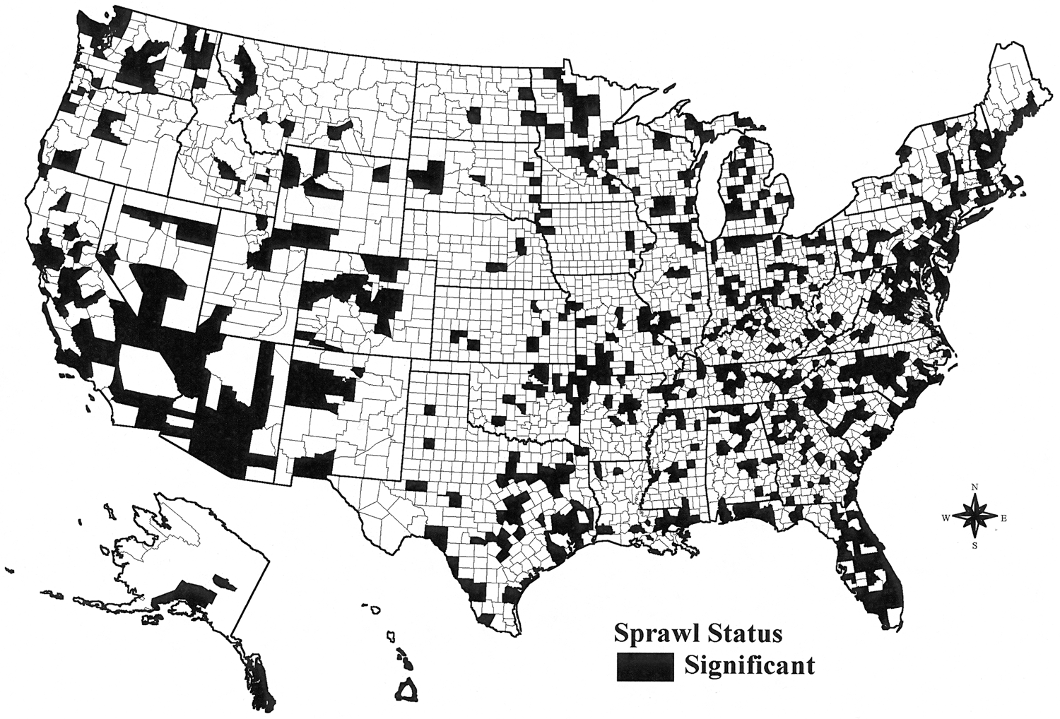
So even though sprawl is believed to be a significant problem in the United States, across the country as a whole, sprawl in a significant sense is taking place in less than 25 percent of U.S. counties. Yet, on a micro basis, sprawl is taking place almost everywhere there is growth: in central cities, behind or immediately adjacent to urban growth boundaries, and even in locations where New Urbanist developments are taking place.

Can Sprawl be Controlled?

What if there was a desire to control sprawl? How successful would such an effort be? In other words, what if an urban growth boundary could be established in each of the 172 Economic Areas (like a Metropolitan Area but incorporating rural counties) of the United States. This growth boundary would hold a portion of growth in urban and suburban counties, away from rural and undeveloped counties.

If this could be done in all Economic Areas to a level of denying at least 25 percent of the growth that would take place in the rural and undeveloped counties, this system could “cure” sprawl in only 420 of 740 counties in which sprawl was taking place. In other words, there is too much space and associated growth in central urban counties in Florida, Arizona, Southern California, Colorado, Nevada, and North/ South Carolina to redirect growth inward without causing these areas to also sprawl, only at a higher density.

FIGURE 2

Projected Sprawl in the United States
Controlled Growth Scenario
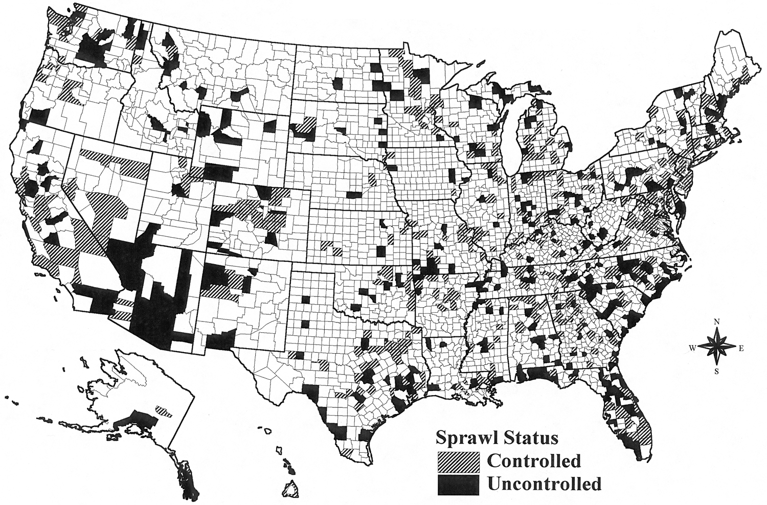

The classic view of moderate growth at the periphery and significant decline at the core, are Northeastern and Midwestern models of growth that are not necessarily present in the Southeast or Southwest. These latter areas are typified by unbridled growth at the periphery and at least moderate growth in central-city counties. Additional growth in central-city counties puts them in a sprawl condition, only at a higher density.

An Alternative to Sprawl—Smart Growth

Smart growth creates a supportive environment to redirect a share of regional growth to central cities and inner suburbs. At the same time, growth pressures are reduced in rural and undeveloped portions of the metropolitan area. Public and private strategies shift the demand for growth from outer suburban and peripheral areas to existing central cities and inner suburbs so that growth is more evenly spread and takes advantage of existing infrastructure. By more evenly distributing growth and taking advantage of sunk infrastructure investment, the regional economy is strengthened, residents’ quality of life is enhanced, and outer-area natural resource systems are protected and restored (Burchell et al. 1998).

Smart growth is not new; this set of practices draws from past growth management, land preservation, community redevelopment practices and influences in the United States. Smart growth has staying power because it is a sensible approach, has a growing national commitment, and is in tune with the new demographic demand for central places by retirees and immigrants (Burchell, Listokin, and Galley 2000).

Localities are pursuing smart growth by controlling peripherally bound growth in Lexington, Kentucky and Portland, Oregon, cities having the two oldest Urban Growth Boundaries (UGBs) in the United States. Development is permitted exclusively within these UGBs; growth is not allowed outside these boundaries. Princess Anne County in Virginia, Richland County in South Carolina, Martin County in Florida, Denver County in Colorado, and numerous other counties have instituted Urban Service Boundaries (USBs) restricting development outside the boundaries unless public services are in place or private developers provide them with their proposed development. The entire state of Florida requires that permission for development be granted only with concurrent public service availability. (Burchell and Listokin 2001).

Twelve states (Florida, Georgia, Hawaii, Maine, Maryland, Minnesota, New Jersey, Oregon, Rhode Island, Tennessee, Vermont, and Washington State) have adopted comprehensive planning and growth management legislation that recommends locations for more or less growth. New Jersey’s most recent state plan (March 2001) specifically maps five planning areas where more and less growth should take place. Maryland encourages growth in priority funding areas through “smart growth” grants to locally complying jurisdictions (Burchell, Dolphin, and Galley 2001).

Inner-area revitalization, an often overlooked element of smart growth, is being undertaken in Atlanta, Georgia. Due to failure to comply with federal water-quality standards, the city is increasing the number of building permits it issues, while Atlanta-area suburban municipalities must limit their growth. In Houston, Texas, to foster city growth, urban neighborhoods can qualify for infrastructure grants to bring urban systems up to par with suburban systems. In Sacramento, California, the City/ County Redevelopment Agency actively assists developers with in-city housing by acquiring land and upgrading city services on that land.

Smart growth also has a transportation dimension. In San Antonio, Texas, the city created a development-incentive toolkit for central city developers that offers impact fee waivers, tax abatements, and densities to make various types of transit feasible. Further, it locates new development and redevelopment with services and public transit. These strategies aim to make regional trips non-automobile and local trips non-motorized. (Burchell and Listokin 2001).

Savings Associated with a Smart or Managed Growth Region

Among other goals, smart growth is touted as an approach that saves resources and tax dollars. These savings occur from reduced and more efficient consumption of land and capital infrastructure, property development, and public services. But what are the specific savings that result from reduced and more efficient consumption of agricultural and environmental lands, roads, and other basic development utilities? How much does smart growth save on the residential and nonresidential property development costs? On the costs to provide basic public safety, public works, and public education services?

Evidence gathered in alternative-growth studies conducted by Rutgers University can help answer these questions and project the results nationally (Burchell 1992, 1997a, 1997b; Burchell and Listokin 1994; Burchell and Moskowitz 1995; Burchell et al. 1999). The figures in Tables 5 and 6 represent the pooled results of the findings in New Jersey, the Delaware Estuary, Michigan, South Carolina, and Florida.

In Table 5 is shown the percent savings that could be achieved by introducing a smart growth regimen in an Economic Area. This regimen would direct a portion of growth to the center, hold another portion closer to already developed areas with an Urban Growth or Urban Service Boundary, and allow the remaining portion of growth to continue outward but be contained in new freestanding development centers. The difference between this regimen and traditional or spread development produces the percentage savings shown in Table 5.
TABLE 5

Savings of Smart Growth – Percentage
(Percentage from Various Regional Studies)

Savings and Results

- Potential Savings of Resources
- Land (overall and special types) 20%-40%
- Infrastructure costs
- Local and state roads 15%-20%
- Water/sewer 8%-15%
- Housing and development costs 4%- 8%
- Fiscal impacts 4%- 8%
- Overall, approximately 15%
[Burchell et al. (1992-2001)]

For a twenty-five year projection period, land conversion losses would amount to 20 to 40 percent less than traditional or sprawl development. The costs to provide infrastructure for local and state roads would be 15 to 20 percent less; for water and sewer, 8 to 15 percent less. In addition, there would be a 4 to 8 percent savings in real estate development costs, and a similar savings in the costs to provide local public services. Overall, there would be about a 15 percent savings in development costs associated with a smart growth regimen.

For numerical savings, savings from the two different alternatives are exposed expressed as coefficients and applied to a projected growth of 25-26 million housing units in the United States over the projection period 2000 to 2025.

The coefficients are derived as follows. An average difference in resource consumption between two future development scenarios (sprawl versus smart growth) is determined, reflecting the numerous localities and conditions in which studies have been undertaken. This average difference is expressed per residential unit (and associated nonresidential growth) and is applied to the future growth of the United States housing stock over the next quarter-century. While far from a scientific exercise, the data have been developed from studies in diverse locations, including slow- and fast-growth states, rural and developed counties, and large and small municipalities. They provide a benchmark for resource savings where no such information exists. (Burchell et al. 2000).

TABLE 6

Savings of Smart Growth – Numerical
(Numbers Nationally 2000-2025: 25 Million Units)

Savings—Areas | Savings—Units | $ Billion
Land | 3.1 mil. acres | 15.5
Local Roads | 91,000 lane miles | 33.13
State Roads | 3,000 lane miles | 2.66
Water Laterals | 2.25 mil. water laterals | 4.64
Sewer Laterals | 2.42 mil. sewer laterals | 4.19
Housing Costs | $5,792/dwelling unit | 144.8
Nonresidential Costs | $861.25/1,000 sq.ft. | 21.53
Fiscal Impacts | $964.02/dwelling unit | 24.1

Total: $250 billion - $10 billion/yr – $10,000/dwelling unit
[Burchell et al. (1992-2001)]

With its emphasis on close-in development, infill, a mixing of land uses, and cluster development, it is estimated that smart growth could save as much as $250 billion (in 2000 dollars) over a 25-year period. This is $10 billion per year or $10,000 per dwelling unit. Three-quarters of the savings would be in the form of housing and development cost savings to developers, new homebuyers and commercial building tenants. Another 15 percent would be in road savings to local and state governments. About six percent would be in land savings to local and state governments. Finally, four percent would be in development utility savings, again to land developers and occupants of new structures.

Revisiting Quality of Life and why Sprawl Works

Given the above savings, why not pursue a smart growth agenda? Smart growth does not threaten quality of life nor does it diminish what society is getting from sprawl. Smart growth does not threaten owning a home and it is consistent with desires for living in communities with increasing property values, good public education, low crime rates, and low taxes. (Nelson 2000).

Smart growth supports reasonable but not excessive automobile use. It relieves outer ring congestion by bolstering inner markets and encourages transit and non-motorized forms of transportation by its central orientation. Smart growth finally seeks to improve and upgrade public services in all areas and contributes to, not avoids, an urban invigoration. (Porter 2000).

Conclusion—Why Invoke Smart Growth?

Why would one invoke smart growth as a replacement for the status quo of traditional or sprawl development. First, the people of the United States can no longer afford two systems of infrastructure—the urban one they are running away from and the rural one they can never catch up with. Both are underutilized and pursuing the dual systems escalates current and future costs geometrically. Second, it is increasingly difficult to tap additional sources of revenue to pay for the hardware of development. Exactions, impact fees, user charges and the like are increasingly being scrutinized by the courts as overstepping local authority and trampling on individual property rights. Third, government cannot tighten its belt anymore. Local governments are sharing all sorts of services and what services can be privatized have already been done so. Finally, regionalization is not occurring. The ability to be part of a larger governmental entity to achieve efficiency and reap the benefits of economies of scale is no longer available. It is not available because it is not desired. Seldom are there city-county consolidations, city-city combinations, or the establishment of a truly multi-county regional government. The only type of consolidation still active is annexation and this is restricted primarily to selected locations in the Southern and Western regions of the United States. Savings must come from another source. That source is the broad base adoption of smart growth policies.

Why will smart growth happen? Smart growth will happen because it does not require either significant resources or global change to implement. It can be done incrementally at a pace that a jurisdiction is comfortable with. It does not immediately threaten any group and, there is reasonable commitment at all levels of government to see it implemented. At the national, state, and local levels, there are innovative examples of smart growth efforts that emerge as pieces of puzzle that are slowly capable of being put in place. In addition, unless significantly curtailed by the events of 9/11 and/or the Iraqi war, immigration is providing a demand for central city housing not experienced in decades. The baby boom retirement will do the same for other non-major city, central places. Baby boomers will begin retiring in six years and continue that phase of their life for the next twenty years. Immigration and retirement will provide the demand for central areas that has never existed in significant fashion in the past. There two forces will demand locations that are central, walkable, of sufficient scale, and interesting. The centers, in the form of older suburbs or freestanding cities in warm and cold climates, serve this role nicely. These are locations that have not fared as well as they should have, given the quest for rural farmettes, single-use large lot residences, or water-based retirement locations in high rise structures on islands. A new quest for centrality will push smart growth possibly even faster than the market will respond to its reasonableness. (Bohl 2000).

References

Bennett, N. (1999). Mixed-use Development: Through the Lenders’ Looking Glass. Community Dividend (Winter): 8.

Broward County. (1998). A Brief Description of the Methodology for Forecasting Broward County’s Population By Age, Race, and Sex (and accompanying data diskette). Broward County, FL: Broward County, FL, Planning Department.

Bohl, C.C. (2000). New Urbanism and the City: Potential Applications and Implications for Distressed Inner-City Neighborhoods. Housing Policy Debate 11, 4: 761-95.

Burchell, R.W. (1992). Impact Assessment of the New Jersey Interim State Development and Redevelopment Plan, Report III: Supplemental AIPLAN Assessment. Trenton, NJ: New Jersey Office of State Planning.

Burchell, R.W. (1997a). Fiscal Impacts of Alternative Land Development Patterns in Michigan: The Costs of Current Development versus Compact Growth. Report prepared for Southeast Michigan Regional Council of Governments.

Burchell, R.W. (1997b). South Carolina Infrastructure Study: Projection of Statewide Infrastructure Costs, 1995-2015. Report prepared by Center for Urban Policy Research, Rutgers University, New Brunswick, New Jersey.

Burchell, R.W.; W.R. Dolphin; and C. Galley. (2000). The Costs and Benefits of Alternative Growth Patterns: The Impact Assessment of the New Jersey State Plan. Report prepared by the Center for Urban Policy Research, Rutgers University, for the New Jersey Office of State Planning, Trenton, New Jersey.

Burchell, R.W.; A. Downs; S. Seskin; T. Moore; N. Shad; D. Listokin; J.S. Davis; D. Helton; M. Gall; and H. Phillips. (1998). Costs of Sprawl Revisited: The Evidence of Sprawl’s Negative and Positive Impacts. Washington, DC: National Academy Press.

Burchell, R.W., and D. Listokin. (1994). The Economic Effects of Trend versus Vision Growth in the Lexington (KY) Metropolitan Area. Report prepared for Bluegrass Tomorrow, Lexington, Kentucky. November.

Burchell, R.W.; D. Listokin; and C.C. Galley. (2000). Smart Growth: More than a Ghost of Urban Policy Past, Less than a Bold New Horizon. Housing Policy Debate 11, 4: 821-79.

Burchell, R.W.; G. Lowenstein; W.R. Dolphin; C.C. Galley; A. Downs; S. Seskin; K. Gray Still; and T. Moore. (2002). Costs of Sprawl 2000. Washington, DC: National Academy Press.

Burchell, R.W., and H.S. Moskowitz. (1995). Impact Assessment of DELEP CCMP versus STATUS QUO on Twelve Municipalities in the DELEP Region. Report prepared for the Local Governments Committee of the Delaware Estuary Program, Philadelphia, Pennsylvania. August 15.

Burchell, R.W.; N. Newman; A. Zakrewsky; and S. Di Petrillo. (1999). Eastward Ho! Development Futures: Paths to More Efficient Growth in Southeast Florida. Report prepared for Florida Department of Community Affairs, Tallahassee, Florida.

Delaphons, John. (1969). Retrospect and Prospect-1969. In Land-Use Controls in the United States. Cambridge, MA: MIT Press.

Landis, J.D. (1995). Imagining Land Use Futures: Applying the California Urban Futures Model. Journal of the American Planning Association (Summer): 336-46.

Leinberger, C. (2001). Financing Progressive Development. A Capital Xchange journal article prepared for The Brookings Institution Center on Urban and Metropolitan Policy and the Harvard University Joint Center for Housing Studies, Washington, DC. May.

Leinberger, C., and R. David. (1999). Financing New Urbanism. Thresholds 18.

Nelson, A.C. (2000). Smart Growth and Housing Policy. Paper presented at the HUD Housing Policy in the New Millennium Conference, October 2-3, Arlington, Virginia.

Porter, D. R. (2000). Building Homes in American Cities: A Progress Report. Draft research report. September 27.

Surface Transportation Policy Project (STPP)/ Center for Neighborhood Technology (CNT). (2000). Driven to Spend. Washington, DC: STPP/ CNT.

U.S. Department of Commerce: 2000. Census of Population and Housing Washington D.C.: Bureau of Census

Wolpert, J., and M.N. Danielsen. (1992). Quality of Life Assessment: Evaluating Impacts on Quality of Life. Chapter in Impact Assessment of the New Jersey Interim State Develoment and Redevelopment Plan: Report I—Research Strategy, by Robert W. Burchell et al. Report prepared for New Jersey Office of State Planning, Trenton, New Jersey. Pp. 323-38.

Woods and Poole Economics. (2000). Complete Economic and Demographic Data Source (CEDDS) 2000. vol. 1. Washington, DC: Woods and Poole.

