Trends in Local Land Use
Ballot Measures, 1986 - 2000

An analysis of city, county and statewide trends

Research by William Fulton
President, Solimar Research Group
Editor & Publisher, California Planning & Development Report

Paul Shigley
Managing Editor, California Planning & Development Report

Alicia Harrison
Research Associate, Solimar Research Group

Peter Sezzi
Research Assistant, Solimar Research Group

Release date: October 2, 2000



973 East Main Street Ventura, CA 93001
Telephone: 805/643-7700
Fax: 805/643-7782
Email: info@solimar.org
Web: www.solimar.org

INTRODUCTION

Over the last few decades, California has become a showcase for local land use related ballot measure activity. In fact, over the last 15 years, there were 610 land use ballot measures, 660 including the November 2000 measures. But while California hosts a significant amount of land use measure activity, little effort has been put forth to understand the changing dynamics of local, county and statewide trends.

Collecting information and results for all countywide and local land use ballot measures from June, November, and selected March ballots between 1986 and 2000, Solimar Research Group has assembled a local land use ballot measure database. Using this database, the goal of this report is to gain a better understanding of land use measure trends throughout California, asking questions like: Have ballot measures migrated over time? Are they geographically concentrated? Do they mostly promote growth or slow it down? Our preliminary results are revealed in the following sections.

STATEWIDE RESULTS

Total Ballot Measures

Between 1986 and 2000, we identified 610 land use measures statewide, 660 including the November 2000 land use measures.

As shown in Chart 1, ballot measure activity has fluctuated significantly throughout the state over the last 15 years. Activity slowed down during the 1990's period of recession, but increased again afterward. With 50 land use measures on the November 2000 ballot, it appears that ballot measure activity is on the rise again in California.

Types of Ballot Measures

Overall, Slow-Growth measures have been more frequent over the 15-year period. Of the total 660 ballot measures, 225 (34%) of them are Pro-Growth and 383 (58%) are Slow-Growth. Another 52 (8%) are Neutral.

Ballot Measure Results

As shown in Chart 2, Slow-Growth measures passed more frequently than Pro-Growth measures up through 1993. From 1994 and 1997, however, this pattern shifted, and Pro-Growth results either tied or exceeded Slow-Growth results. Historic patterns returned from 1998 through 1999. Pro-Growth results exceed Slow-Growth results again in 2000, but this only reflects the March election results. 2000 results may change after the November election. Overall, 57% of all ballot measure results were Slow-Growth (either "Slow-Yes" or "Pro-No") and 43% of all ballot measures were Pro-Growth (either "Pro-Yes" or "Slow-No") over the 15-year period.

- AGGREGATE OF CITY AND COUNTYWIDE RESULTS

Total Ballot Measures

Overall, the most ballot measure activity (measured as the aggregate of city and countywide measures) has historically been concentrated in counties in the Bay Area, Metropolitan Los Angeles, and San Diego County. Over the 15-year period, San Diego County (80 ballot measures) had the most ballot measures over the 15-year period, almost 20 more than the second highest county, Los Angeles County (64 ballot measures).

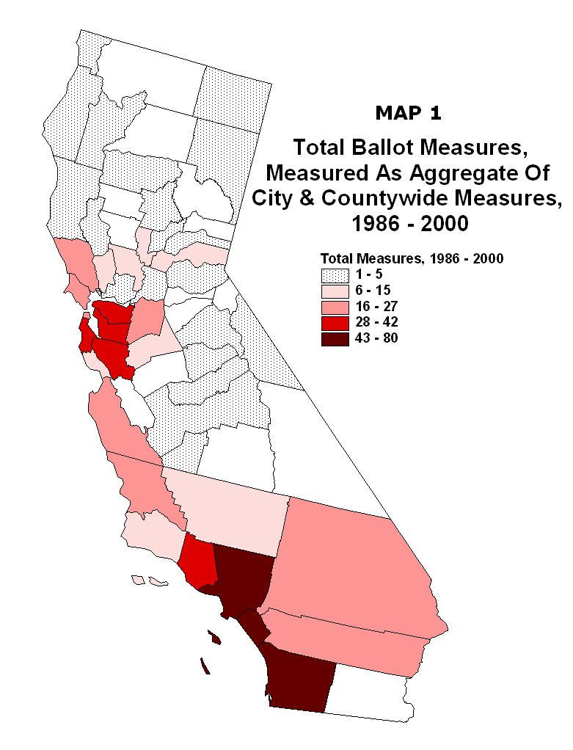
Types of Ballot Measures

By aggregating county totals into regions, we are able to identify regional differences in ballot measure activity. As Chart 3 shows, Slow-Growth measures represent the most measures in all regions except for the Central Valley and the North Coast region. In Southern California, Slow-Growth measures represent more than double the number of Pro-Growth measures. In the San Diego region, however, Pro-Growth and Slow-Growth measure totals are similar.

Ballot Measure Results

A majority of the regions had Slow-Growth results between 1986 and 2000. The exceptions were the North Coast region, the Upper Sacramento/Mountain Counties region, and San Diego County, as shown in Chart 4.

- RESULTS BY CITY

By mapping ballot measures by city over time (does not include countywide measures), we were able to identify the changing patterns and migration of ballot measures throughout the state. Overall results indicate that from 1986 through 2000 ballot measure activity has:

- Concentrated in the Los Angeles Metropolitan Area, Bay Area, and San Diego County;
- Occurred closer to coastal areas than inland regions;
- Located near older cities;
- Spread out more in Southern California compared with the Bay Area.

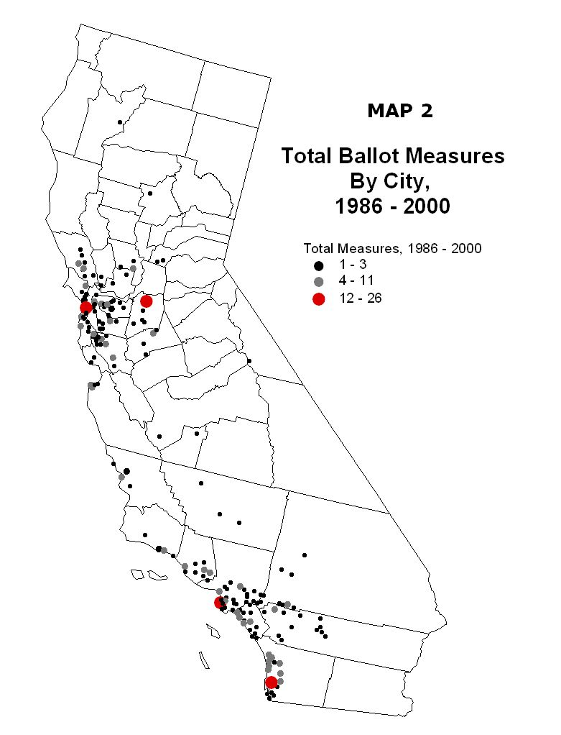
Total Ballot Measures By City

In the Bay Area region, ballot measure activity is primarily concentrated in the East and South Bay counties, with varying concentrations over the 15-year period. Over the last four years, however, ballot measure activity has increasingly extended into more North Bay counties. Overall, there seems to be a tighter concentration of ballot activity in the Bay Area compared to Southern California.

In the Southern California region, activity started out more closely concentrated around Los Angeles County between 1986 and 1990, but then pushed out significantly, especially between 1991 and 1995. More distant localities in Ventura, Riverside and San Bernardino Counties began to experience more ballot measure activity during this time, which has continued into recent years.

By city, the highest concentrations of ballot measure activity do not seem to follow a geographical pattern, as shown in Table 1. Many of the different state's regions, coastal and inland, are represented. As expected, however, from 1986 through 2000, San Francisco and San Diego experienced the most ballot measure activity.

Overall, ballot measure activity has decreased by nearly half in the Southern California area, from 93 ballot measures from 1986 through 1990 to 48 ballot measures from 1996 through November 2000. Activity in the Bay Area region has also decreased, but not by nearly as much — from 99 ballot measures from 1986 through 1990 to a total of 86 from 1996 through 2000.

Types of Ballot Measures

Over the 15-year period, Slow-Growth measures have been more concentrated in the coastal communities of the South Bay and East Bay region of the Bay Area. Pro-Growth measures are generally more spread out geographically.

From 1986 through 1990, communities in Contra Costa, Alameda and Santa Clara counties saw a significant number of Slow-Growth measures. The period from 1991 through 1995 followed the same pattern, but with much less activity. From 1996 through 2000, however, ballot measure activity, particularly Slow-Growth measures, moved outward to the North Bay region, especially Sonoma County.

In the Southern California area from 1986 through 1990, Slow-Growth measures have primarily concentrated in the coastal communities in Orange and San Diego Counties, as well as coastal and inland counties in Los Angeles County. Pro-Growth measures mostly concentrated in Los Angeles and San Diego Counties.

However, from 1991 through 1995 ballot measure activity began to spread. More and more measures occurred farther away from coastal cities, and during this period they were primarily Pro-Growth. This trend continued through 1996 to 2000, with more distant counties such as Ventura and San Bernardino showing increased activity, particularly Slow-Growth measures.

Ballot Measure Results

In the Bay Area, both Slow-Growth and Pro-Growth results concentrated in the coastal communities. Overall, Pro-Growth results were more geographically dispersed in the East Bay and South Bay and Slow-Growth results were more geographically dispersed in the North Bay.

Overall, 41% of all measures in the Bay Area region were passed to promote growth, while 59% were passed to slow growth down.

In Southern California, overall Slow-Growth results were more concentrated in coastal communities and inland Los Angeles County cities. Overall Pro-Growth results were more geographically dispersed.

Overall, nearly 43% of all measures in the Southern California region were passed to promote growth, while 57% were passed to slow growth down. This shows a higher Pro-Growth passage rate and a lower Slow-Growth passage rate for Southern California than in the Bay Area.

- COUNTYWIDE RESULTS

Total Ballot Measures

Countywide measures (does not include city ballot measures) are also concentrated in the Bay Area and Metropolitan Los Angeles regions, but they are much more frequent in counties along the Central Coast and in the Central Valley. Overall, the most ballot measure activity was from 1986 through 1990 and 1996 through 2000, when activity concentrated primarily in the Central Coast and Bay Area counties.

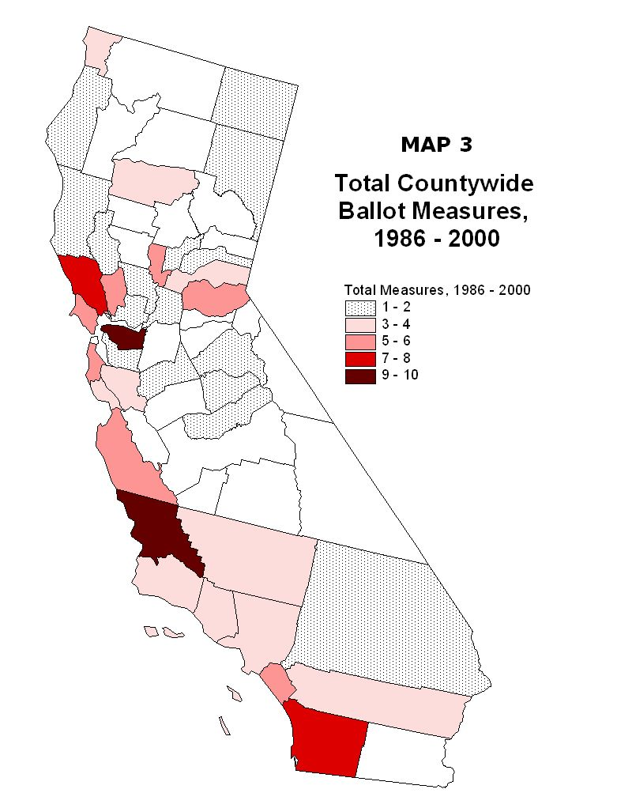
Types of Ballot Measures

Similar to the ballot measure description by city, countywide Slow-Growth measures are more concentrated in coastal counties, and countywide Pro-Growth measures are more geographically diverse. Pro-Growth measures are primarily concentrated in the Central Coast counties, but also extend into the North Coast, upper Central Valley, and North Bay Area counties. Slow-Growth measures are mostly concentrated in the coastal counties throughout the state: the Central Coast, Los Angeles Metropolitan Area, as well as San Diego County. Slow-Growth measures are present in both the North and South Bay regions of the Bay Area.

Ballot Measure Results

Overall countywide Pro-Growth results (over 50% passage) are primarily concentrated in the Upper Sacramento and Mountain Counties regions. And in Central and Southern California, Pro-Growth results occurred in Santa Barbara, Orange and Riverside counties. However, most counties show less than a 50% passage rate for Pro-Growth measures.

Overall countywide Slow-Growth results (over 50% passage) are concentrated in the Central and Southern California coastal counties of Los Angeles, Ventura, San Luis Obispo and Monterey counties. Slow-Growth results are also concentrated in the South Bay and North Bay Areas of the San Francisco Bay Area region.

- CONCLUSION

By aggregating and mapping ballot measure totals, types, and results for California cities and counties over the last 15 years, we have begun to identify trends in local land use measures. Overall, our findings reveal the following:

- During our 15-year study period, there have been substantially more Slow-Growth measures on the ballot than Pro-Growth measures.

- Counting the results of all measures, the electorate has voted to limit growth 57% of the time.

- Although the total number of local land use ballot measures has decreased since the high period of 1986 through 1990, ballot measures activity is on the rise again — especially this year. The San Francisco Bay Area has experienced substantial ballot measure activity since 1996.

- Ballot measure activity appears to correspond with periods of economic recession and prosperity in California. Ballot measure activity was greatest during the boom years of 1986 through 1990, subsided during the recession period of 1991 through 1995, and picked up as the economy strengthened from 1996 through 2000. Voters appear more willing to limit urban growth during times of economic prosperity.

- However, ballot results have not followed the same trend. Slow-Growth ballot victories have declined over time. From 1986 through 1990, the Slow-Growth position won 60% of the time. This figure dropped to 56% from 1991 through 1995, and it dropped further to only 50% from 1996 through March of 2000. This drop has occurred mostly because Pro-Growth measures have passed more often, not because Slow-Growth measures have failed more often.

- Overall, ballot measure activity in Southern California decreased by approximately half during our 15-year study period. The number of ballot measures also decreased in the Bay Area, but not as sharply as in the southern part of the state.

- City and countywide measures have been most common in urban coastal areas, and there has been minimal migration of land use ballot measures to other regions. In the Bay Area, ballot measures have historically concentrated in the East Bay and South Bay; however, activity has spread to the North Bay since 1996. In Southern California, ballot measure activity that was concentrated in Los Angeles and Orange counties during the 1986 to 1990 period has spread to Ventura and San Bernardino counties.

- San Diego and Los Angeles counties had the most ballot measures (when counting both city and countywide measures). Those two counties have accounted for nearly 22% of all local land use ballot measures in the state since 1986. The cities of San Francisco and San Diego had more land use ballot measures than any other cities. Contra Costa and San Luis Obispo counties had the most countywide ballot measures.

- Thirty-seven Urban Growth Boundary/SOAR-like measures have appeared on local ballots around the state since 1986, including 11 on the ballot in November of 2000. Of the 25 legitimate measures that appeared between 1990 and March 2000, only one failed. Twenty of the 37 measures have appeared in just two counties, Ventura and Sonoma. Six more have appeared in Alameda County.

Through varying degrees of ballot measure activity at the city, county and regional level, local land use measures are shown to have dynamic trends over time. The trends are not only interesting, but help to paint the "big picture" of ballot-box land use planning in California.

Copyright © 2000 Solimar Research Group Inc.
All rights reserved.
This publication or any information contained herein may not be reproduced in any form without the express written consent of Solimar Research Group Inc.

